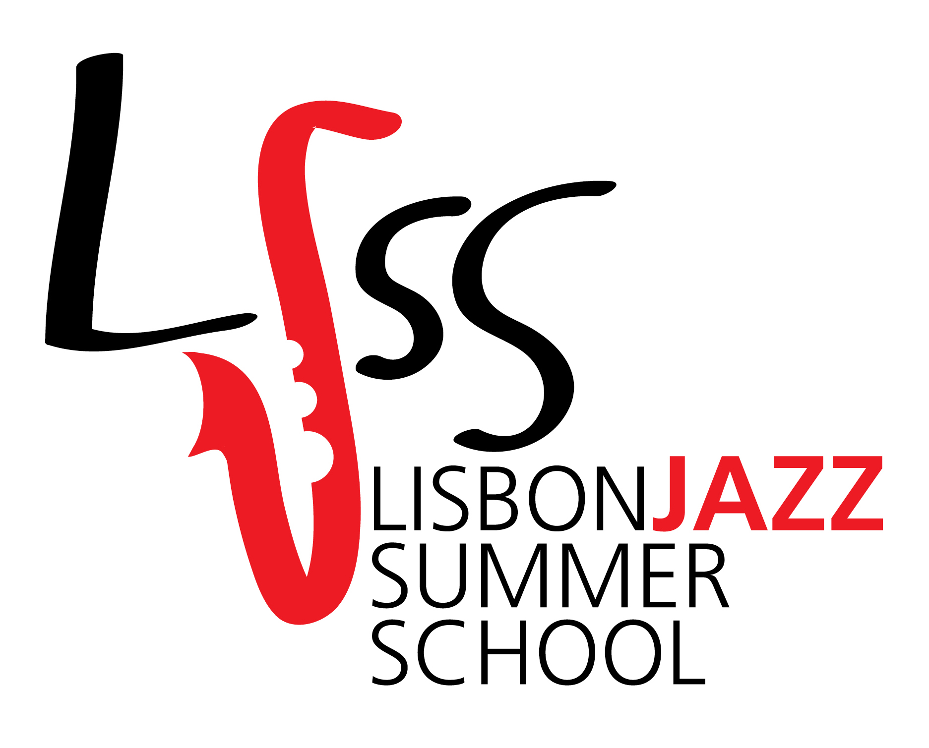
LISBON | JULY 18 to 23 | 2016

BECCA STEVENS, GRETCHEN PARLATO & REBECCA MARTIN
TOGETHER AS
“TILLERY”

PERFORM AND LEAD A 6 DAYS JAZZ SUMMER COURSE
AT THE
LISBON JAZZ SUMMER SCHOOL 2016
@ CENTRO CULTURAL DE BELÉM

SUMMER COURSE:
“METHODS, PROCESS AND PRACTICE OF SONGWRITING,
COLLABORATION, PERFORMANCE AND BAND LEADING”

LECTURED BY
TILLERY:
BECCA STEVENS
GRETCHEN PARLATO
REBECCA MARTIN

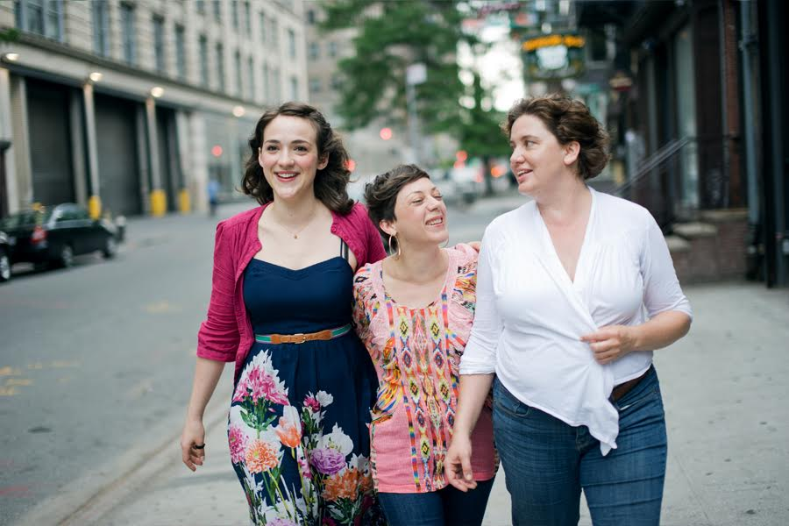

“Three of the sharpest and most open-minded jazz singers in (or out of) town”
Time Out Magazine (New York)

"Tillery, a Vocal Dream Team.”
JazzTimes

There’s no one out there like Gretchen.”
Wayne Shorter

“Rebecca Martin is a delight.”
Charles Lloyd

"Becca Stevens is effortlessly charming in her stage demeanor and lights up like a firefly in performance. ﻿She is a treasure﻿."
Kurt Elling

(Click here to read more about what is being written and said about Tillery)

For the 6th edition of the Jazz Summer Course, the LJSS invited TILLERY, a collaborative project created by Rebecca Martin, Becca Stevens and Gretchen Parlato to lead the Summer Course, directed to professional musicians and advanced students from any country.

Participants in the Summer Course will have the opportunity to experience, discuss and improve individually and in groups, the methods and techniques of composition, writing and arrangements, band-leading and performance with three of New York’s most critically acclaimed singers and songwriters.

“TILLERY” CONCERT | JULY 21 | 21h00 | Small Auditorium @ CCB
JAZZ SUMMER COURSE | JULY 18 TO 23 | from 10h00 to 18h00 | CCB

- Open to all instruments >16 years old.
- Directed to advanced students and professional musicians
- Tuition: 270 euros (lunch included)
- Language: English
- Click here to learn how to enroll.
- Detailed structure of the course available here.
- It is possible to attend the course as a listener. More information here.

It will be given priority to applications received before June 5.

The three of us all share the same desire to connect with musicians in an intimate setting – with students who are dedicated to their craft.
Sharing ourselves in this manner is a very natural part of what we all do.
[Rebecca Martin]
Writing, learning, and composing is only half of the joy of music for me.
Sharing these gifts makes up the other half.
I consider teaching to be the most direct and meaningful way that I can share music.
Performing is blissful, but the impression that can be made though teaching,
both for the teacher and the student, has the potential to be far deeper.
[Becca Stevens]
Songwriting is a gift. It’s a gift to ourselves and to those who listen.
In our workshop, we want to open up, explore and share the process with other songwriters in our workshop, connecting and learning from each other
on all levels technical, spiritual, and emotional.
[Gretchen Parlato]

LISBON JAZZ SUMMER SCHOOL
Artistic Direction
Alexandra Ávila Trindade and João Godinho
Executive Production
Orelha Viva

HOSTED BY
Centro Cultural de Belém

SUPPORTED BY
Centro Cultural de Belém
Hot Clube de Portugal
Smooth FM
Fernando Rosado Pianos
Jazz.PT

MORE INFORMATION
www.lisbonjazzsummerschool.org (in Portuguese)
www.eng.lisbonjazzsummerschool.org (in English)
ljss.participants@gmail.com
(+351) 967 435 310

LISBON JAZZ SUMMER SCHOOL
MUSICIANS INVITED IN PREVIOUS EDITIONS

LJSS 2014
GUILLERMO KLEIN: COMPOSITION FOR JAZZ ENSEMBLE

LJSS 2012
LAWRENCE D. "BUTCH" MORRIS: CONDUCTION ® ATELIER

LJSS 2010
DANILO PEREZ QUINTET
Danilo Perez - Piano
Rudresh Mahanthappa - Saxofone
Ben Street - Contrabaixo
Adam Cruz - Bateria
Rogério Boccato - Percussão

LJSS 2009
GREG OSBY SIX
﻿Greg Osby - Saxofone
Sara Serpa - Voz
Joseph Lepore - Contrabaixo
Nir Felder - Guitarra
Adam Birnbaum - Piano
John Davis - Bateria

LJSS 2008
MULGREW MILLER & WINGSPAN
Mulgrew Miller - Piano
António Hart - Saxofone
Steve Nelson - Vibrafone
Rodney Green - Bateria
Ivan Taylor – Contrabaixo

OTHER PROJECTS BY ORELHA VIVA
BIG BAND JÚNIOR | www.bigbandjunior.org

